1. **Assume you intercepted the following ciphertext. Using a statistical attack, find the plaintext**

**"XLILSYWIMWRSAJSVWEPIJSVJSYVQMPPMSRHSPPEVWMXMWASVX-LQSVILYVVCFIJSVIXLIWIPPIVVIGIMZIWQSVISJJIVW"**

1. **Write a Python script to encrypt using Rail Fence (Zig zag ) with three rows and with key (ONE).**

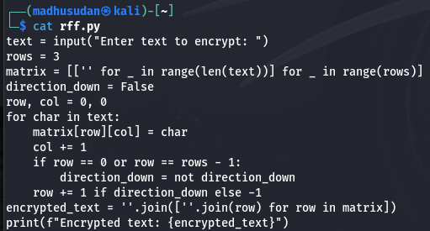

**Output**

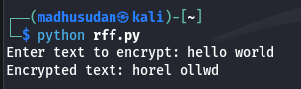

1. **Write a python script to encrypt columnar transposition**

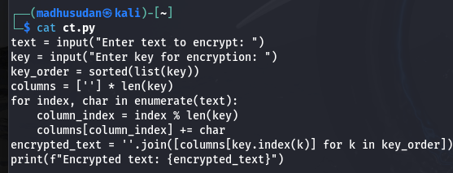

**Output**

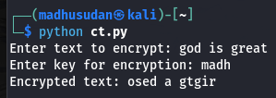

1. **Write a Python script to decrypt Rail Fence Cipher**

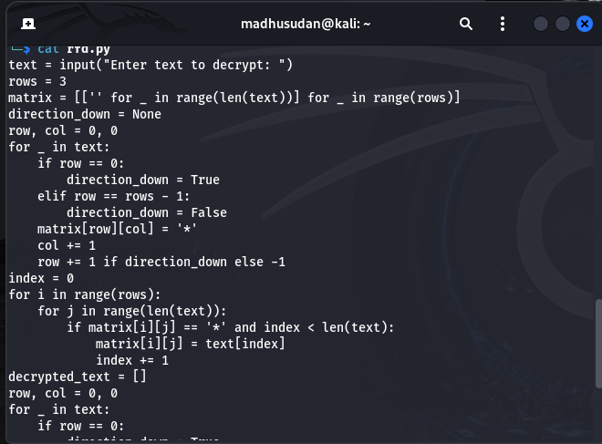

**Output**

